
Week 1

EDA and Research Questions
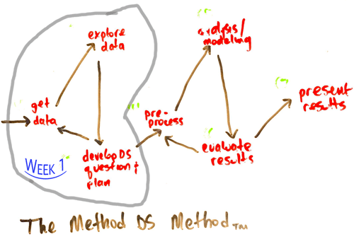Illustration 1: Week 1 - MDS Method

Problem Statement
Create a successful app or website that accentuates positive news according to the tastes and preferences of a user.

Research Questions
- What are the emotions that the articles or news need to elicit to ensure enhanced emotional health?
- What will be the business model / unit economics?
- What is the best set of filters to offer the users a curated newsfeed? How do we define “best” in this context?
- Market survey: What are some similar products out there? What is the current market size?
- What can be the “X” factor differentiating our product from others? Where can the product “fit” in the current ecosystem?
- Can we partner with “activities” that are associated with wholesomeness? Eg. Yoga, Environmentalism, Hiking, Sports, Volunteering, Farmer’s Market groups etc.
- Do we need to ensure political neutrality to target all sections? What is the target demography?
- What are the standard industry techniques used for curating a filtered newsfeed?
- What kind of Minimum Viable Product can we build and how can we validate it?
- What are the metrics needed to measure success?
- What is the marketing strategy best needed to promote this product?
- How can we ensure user retention? How do we make them crave our product?
- In the long term, how do we measure whether this product has led to a greater wholesome state of mind for the user? How do we measure the product has succeeded in its mission?

Emotions or Qualities to Elicit
Compassion Goodwill Joy Calm Peace Optimism Reflection Discipline Appreciation Conscientiousness Openness Prudence Self-respect Generosity Moderation Resilience Equanimity Tolerance Gratitude Urgency
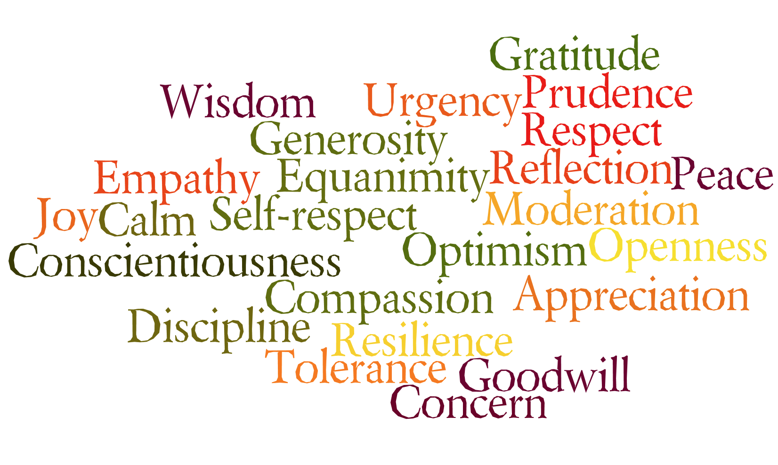Illustration 2: Positive Emotions Word Cloud

Market Research:
A simple Google search for positive news creates the following results:
URL | What is it? | What is the business model? | What are the categories?
https://www.positive.news/ | Website: Good news about good things.  UI/UX: Simple and elegant | Online magazine subscription and donation. | Society, Economics, Science, Environment, Lifestyle, Perspective
https://www.sunnyskyz.com/

